Modify VPC Subnet for Private

Create Route table: private-route - Associated with the subnet

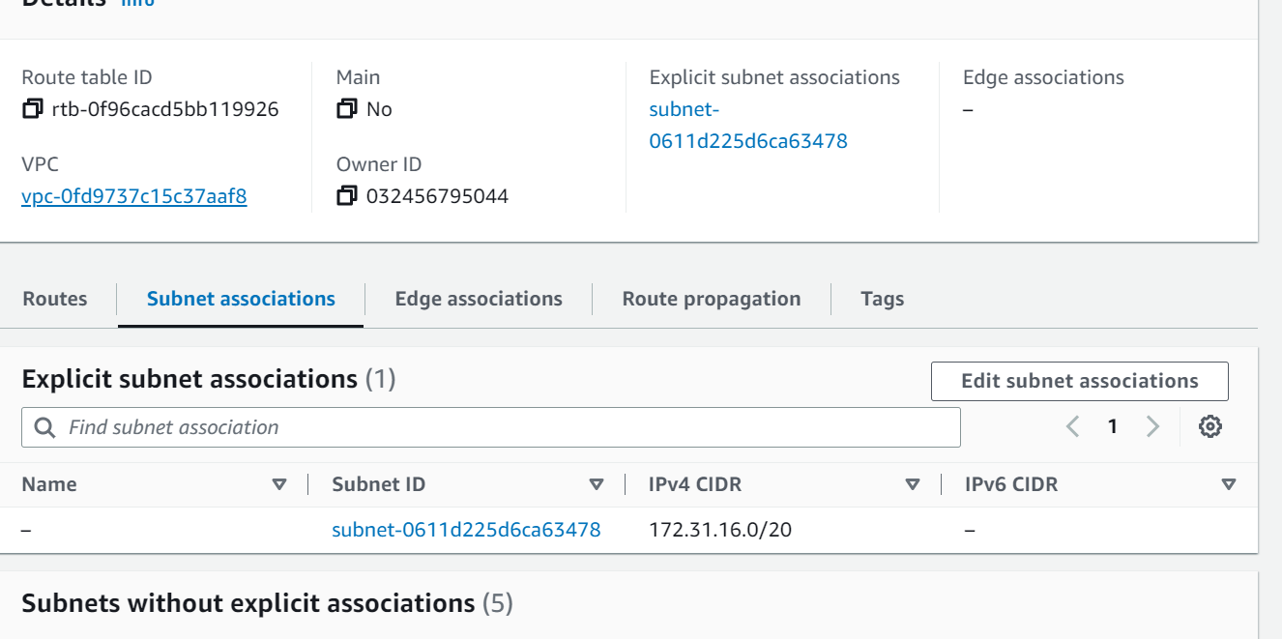

Create vpc endpoint

